The Stock Exchange of Hong Kong Limited takes no responsibility for the contents of this announcement, makes no representation as to its accuracy or completeness and expressly disclaims any liability whatsoever for any loss however arising from or in reliance upon the whole or any part of the contents of this announcement.
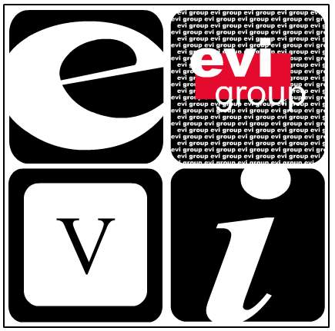.

EVI Education Asia Limited
EVI 教育亞洲有限公司*
( Incorporated in the Cayman Islands with limited liability)
(Stock Code: 8090)

NOTICE OF BOARD MEETING

The board of directors (the “Board”) of EVI Education Asia Limited (the “Company”) hereby announces that a meeting of the Board will be held at Rooms 2505-8, 25th Floor, Worldwide House, 19 Des Voeux Road Central, Central, Hong Kong on 8 May 2007 (Tuesday) at 4:15 p.m. for the following purposes:

- To consider and approve the unaudited first quarterly results of the Company and its subsidiaries for the three months ended 31 March 2007 (the “Quarterly Results”).

- To approve the Quarterly Results announcement to be published on the website of the Growth Enterprise Market of The Stock Exchange of Hong Kong Limited.

- To consider the payment of an interim dividend, if any.

- To consider the closure of the Register of Members, if necessary.

- To transact any other business.

By order of the Board
EVI Education Asia Limited
Hui Hin Sing
Company Secretary

Hong Kong, 24 April 2007

As at the date of this announcement, the Board of the Company comprises seven directors, of which (i) three are executive directors, namely Ms. Ip Kit Yee, Kitty, Mr. Pong Wai San, Wilson and Mr. Lau Wai Shu; (ii) one non-executive director, namely Mr. Tsang Link Carl, Brian; and (iii) three are independent non-executive directors, namely Mr. Koo Fook Sun, Louis, Mr. Sha Pau, Eric and Mr. Ying Wing Cheung.

The directors of the Company collectively and individually accept full responsibility for this announcement which is given in compliance with the requirements (Rules Governing the Listing of Securities on the Growth Enterprise Market) of The Stock Exchange of Hong Kong Limited. The directors of the Company, having made all reasonable enquiries, confirm that, to the best of their knowledge and belief:- (1) the information contained in this announcement is accurate and complete in all material respects and not misleading; (2) there are no other matters the omission of which would make any statement in this announcement misleading; and (3) all opinions expressed in this announcement have been arrived at after due and careful consideration and are founded on bases and assumptions that are fair and reasonable.

This announcement will remain on the GEM website on the “Latest Company Announcements” page for at least 7 days from the day of its posting.

* For identification purposes only

