The Stock Exchange of Hong Kong Limited takes no responsibility for the contents of this announcement, makes no representation as to its accuracy or completeness and expressly disclaims any liability whatsoever for any loss however arising from or in reliance upon the whole or any part of the contents of this announcement.
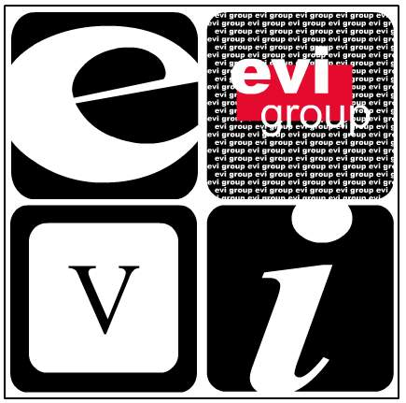.

EVI Education Asia Limited
EVI 教育亞洲有限公司*
( Incorporated in the Cayman Islands with limited liability)

(Stock Code: 8090)

NOTICE OF BOARD MEETING

The board of directors (the “Board”) of EVI Education Asia Limited (the “Company”) hereby announces that a meeting of the Board will be held at 9th Floor, Tai Sang Commercial Building, 24-34 Hennessy Road, Hong Kong on 7 March 2007 (Wednesday) at 4:15 p.m. for the following purposes:

- To consider and approve the audited consolidated financial statements of the Company and its subsidiaries for the year ended 31 December 2006 (the “Annual Results”).

- To approve the announcement of the Annual Results to be published on the website of the Growth Enterprise Market of The Stock Exchange of Hong Kong Limited.

- To consider the payment of a final dividend, if any.

- To consider the closure of the Register of Members, if necessary.

- To consider the time and venue of the forthcoming annual general meeting of the Company.

- To consider and approve, subject to the shareholders’ sanction, the granting to the directors the general mandates to purchase and issue shares.

- To transact any other business.

By order of the Board
EVI Education Asia Limited
Hui Hin Sing
Company Secretary

Hong Kong, 23 February 2007

* For identification purposes only

As at the date of this announcement, the Board comprises seven directors, of which (i) three are executive directors, namely Mr. Chu Tak Long, Mr. Pong Wai San, Wilson and Mr. Lau Wai Shu; (ii) one is non-executive director, being Mr. Tsang Link Carl, Brian; and (iii) three are independent non-executive directors, namely Mr. Koo Fook Sun, Louis, Mr. Sha Pau, Eric and Mr. Ying Wing Cheung.

The directors of the Company collectively and individually accept full responsibility for this announcement which is given in compliance with the requirements (Rules Governing the Listing of Securities on the Growth Enterprise Market) of The Stock Exchange of Hong Kong Limited. The directors of the Company, having made all reasonable enquiries, confirm that, to the best of their knowledge and belief:- (1) the information contained in this announcement is accurate and complete in all material respects and not misleading; (2) there are no other matters the omission of which would make any statement in this announcement misleading; and (3) all opinions expressed in this announcement have been arrived at after due and careful consideration and are founded on bases and assumptions that are fair and reasonable.

This announcement will remain on the GEM website at www.hkgem.com on the “Latest Company Announcements” page for at least 7 days from the day of its posting.

