This announcement is made at the request of The Stock Exchange of Hong Kong Limited. The Stock Exchange of Hong Kong Limited takes no responsibility for the contents of this announcement, makes no representation as to its accuracy or completeness and expressly disclaims any liability whatsoever for any loss however arising from or in reliance upon the whole or any part of the contents of this announcement.
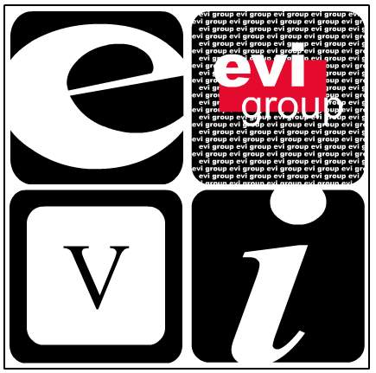

EVI Education Asia Limited
EVI 教育亞洲有限公司*
( Incorporated in the Cayman Islands with limited liability)

(Stock Code: 8090)

ANNOUNCEMENT

This announcement is made pursuant to rule 17.11 of the GEM Listing Rules.

The board of directors (the “Board”) of EVI Education Asia Limited (the “Company”) has noted the recent increase in price of the shares of the Company and wishes to state that the Board is not aware of any reasons for such increase.

The Board also confirms that there are no negotiations or agreements relating to intended acquisitions or realisations which are discloseable under Chapters 19 and 20 of the GEM Listing Rules, neither is the Board aware of any matter discloseable under the general obligation imposed by rule 17.10 of the GEM Listing Rules, which is or may be of a price-sensitive nature.

Made by the order of the Board, the directors of which collectively and individually accept responsibility for the accuracy of this announcement.

By order of the Board
Chu Tak Long
Director

Hong Kong, 15 February, 2007

As at the date of this announcement, the Board of the Company comprises seven directors, of which (i) three are executive directors, namely Mr. Chu Tak Long, Mr. Pong Wai San, Wilson and Mr. Lau Wai Shu; (ii) one is non-executive director, being Mr. Tsang Link Carl, Brian; and (iii) three are independent non-executive directors, namely Mr. Koo Fook Sun, Louis, Mr. Sha Pau, Eric and Mr. Ying Wing Cheung.

The directors of the Company collectively and individually accept full responsibility for this announcement which is given in compliance with the requirements (Rules Governing the Listing of Securities on the Growth Enterprise Market) of The Stock Exchange of Hong Kong Limited. The directors of the Company, having made all reasonable enquiries, confirm that, to the best of their knowledge and belief:- (1) the information contained in this announcement is accurate and complete in all material respects and not misleading; (2) there are no other matters the omission of which would make any statement in this announcement misleading; and (3) all opinions expressed in this announcement have been arrived at after due and careful consideration and are founded on bases and assumptions that are fair and reasonable.

This announcement will remain on the GEM website on the “Latest Company Announcements” page for at least 7 days from the day of its posting.

* For identification purposes only

